

Deliverable 6 - Release 2

Project C.A.T. - Capital Activity Tracker

Group: “The Stockings”

Clayton Williams, Kaitlyn Lee, Brandon Horner, Savannah Fischer

Course: CS 386 Software Engineering, Spring 2018

Instructor: Marco Gerosa

GitHub Link: <https://github.com/kdl222/CAT>

1. **Description**

CAT is a stock market analysis application that brings data visualizations and information-gathering together in an easily-accessible and affordable program, making it perfect for new and experienced stock traders alike. Equipped with live transaction suggestions and in-depth company evaluations, CAT allows traders to make more informed financial decisions than could be reliably accomplished alone.

Users can create a secure and private account on the CAT web application, where they can easily view and remove any stocks, and their accompanied real-time activity graphs, that they have selected to watch. The ranges of time covered by stock activity graphs can be adjusted to the user’s preference. Users can view a news feed containing many articles. Users can add and remove keywords in a keyword manager, set the weight of each word, and watch as the manager parses through the news feed to show the net weight of each article.

GitHub Link: <https://github.com/kdl222/CAT>

Trello Link: <https://trello.com/b/wivdXgKk/cs386>

1. **Implemented Requirements**

**Note: From the previous deliverable, we were not able to do automated tests, so Dr. Gerosa gave us the okay to record a video of our web application working. I emailed Dr. Gerosa about this deliverable, but did not hear anything back from him. The demo showcases that our web application loads correctly and our features work correctly.**

**Here is a screenshot of the email with no response.**

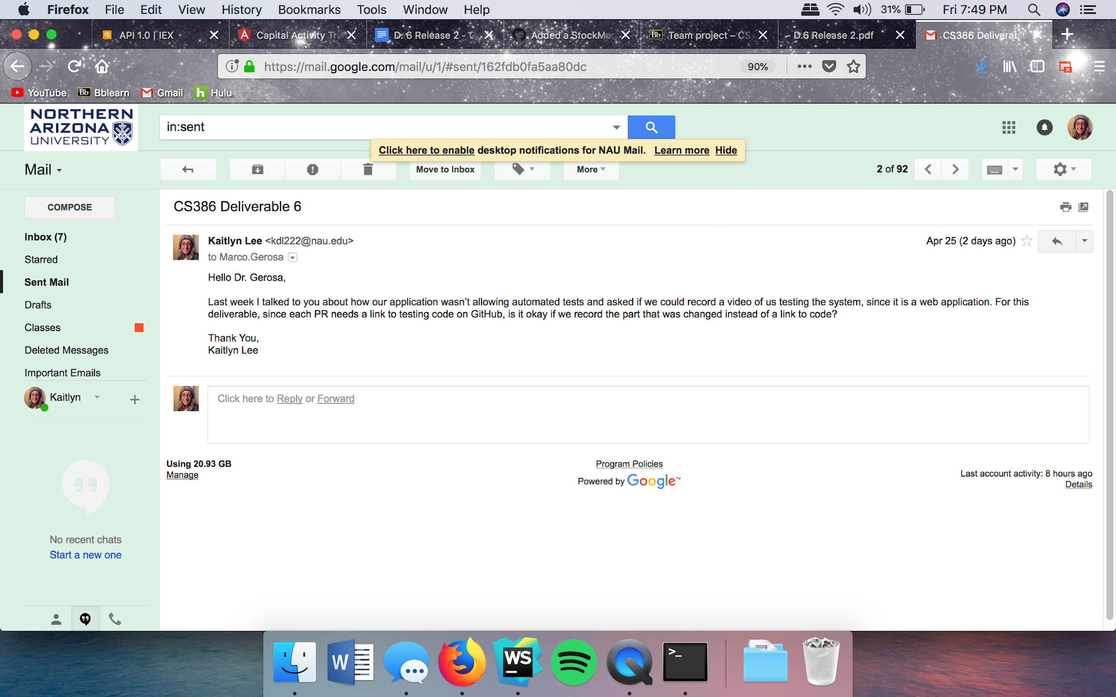

Requirements (user stories, issues, or use cases that you implemented for this release):

* Ability for users to log in in a way that allows firebase to store information.
  + Link to Trello card(s): <https://trello.com/c/irQPAbog>
  + Name of who implemented the requirement: Kaitlyn Lee
  + Link to the pull request on GitHub that refers to this implementation:

<https://github.com/kdl222/CAT/pull/11> (If you go to files changed, you can see that I changed the authService file)

* + Name of who reviewed and approved the pull request: (Merged by Kaitlyn, but she was showing Savannah how GitHub works) Savannah approved pull request.
  + GitHub Link to the automated testing code of the feature (for this release, all features should have automated tests): Not automated tests.
  + A print screen that depicts the implemented feature: Screenshot of Firestore, the database we use.

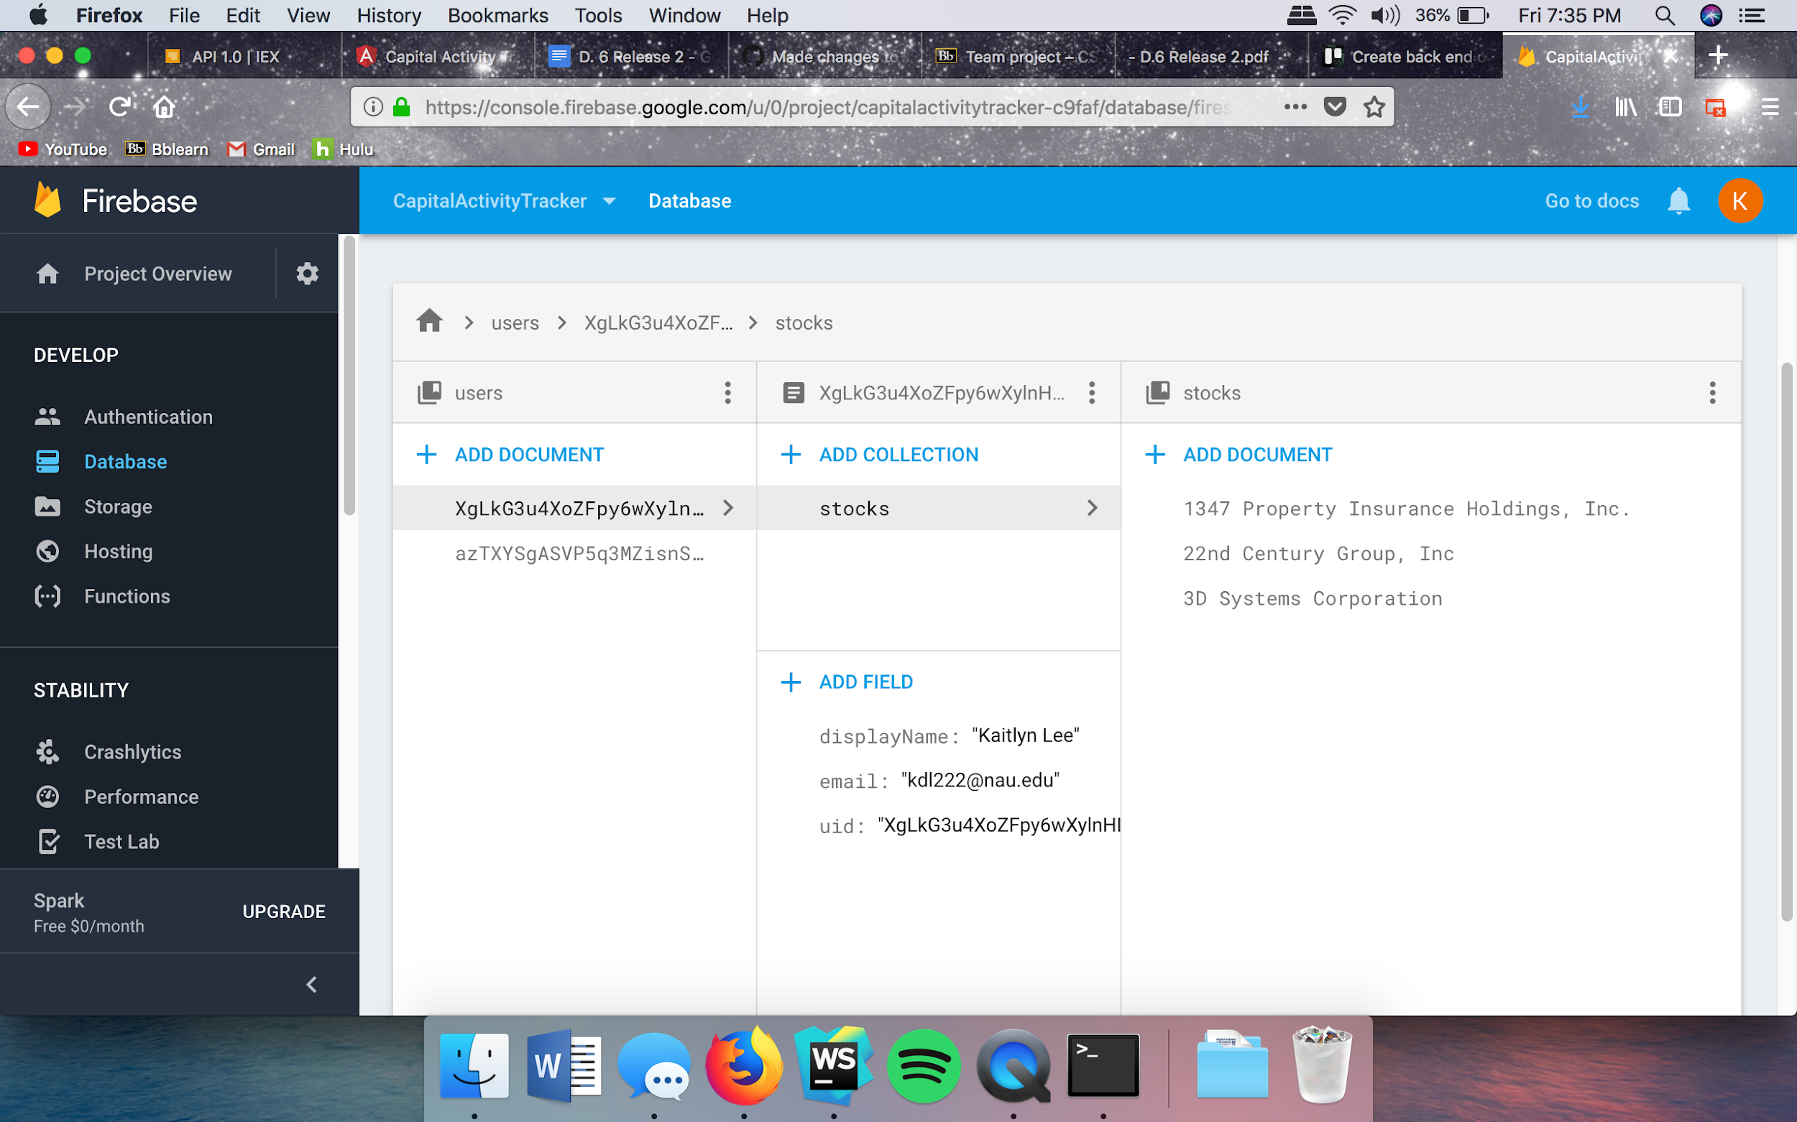

* Ability to favorite a specific stock and display stock on mypage
  + Link to Trello card(s): <https://trello.com/c/7sgoJdXY>, <https://trello.com/c/BsGt6ORn>, <https://trello.com/c/7sgoJdXY>
  + Name of who implemented the requirement: Kaitlyn
  + Link to the pull request on GitHub that refers to this implementation: <https://github.com/kdl222/CAT/pull/19>
  + Name of who reviewed and approved the pull request: Savannah Fischer
  + GitHub Link to the automated testing code of the feature (for this release, all features should have automated tests): We cannot do automated tests, as stated above.
  + A print screen that depicts the implemented feature:

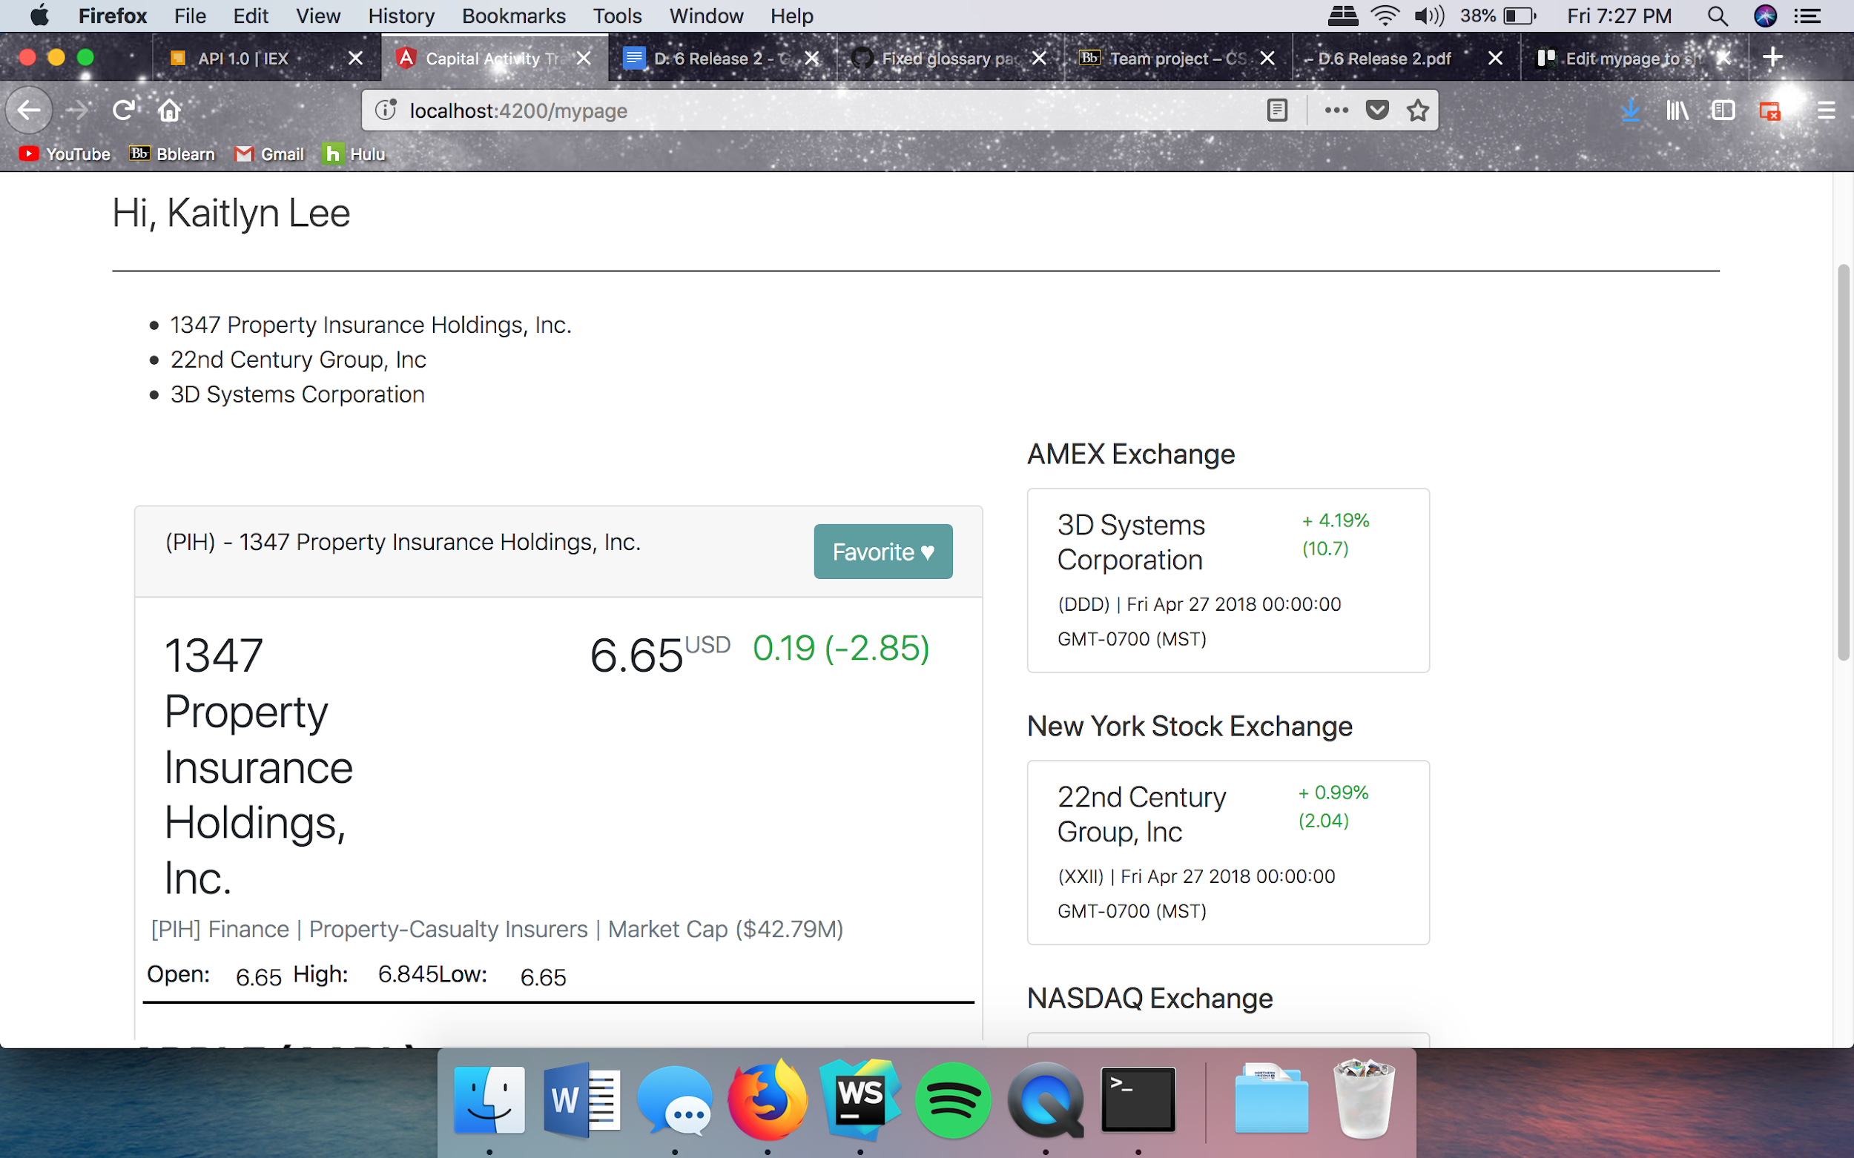

* Live updates and graphs for stocks
  + Link to Trello card(s): <https://trello.com/c/MQ7sqOkq/>
  + Name of who implemented the requirement: Adam
  + Link to the pull request on GitHub that refers to this implementation: <https://github.com/kdl222/CAT/pull/9>
  + Name of who reviewed and approved the pull request: Kaitlyn
  + GitHub Link to the automated testing code of the feature (for this release, all features should have automated tests): We cannot do automated tests, as stated above.
  + A print screen that depicts the implemented feature:

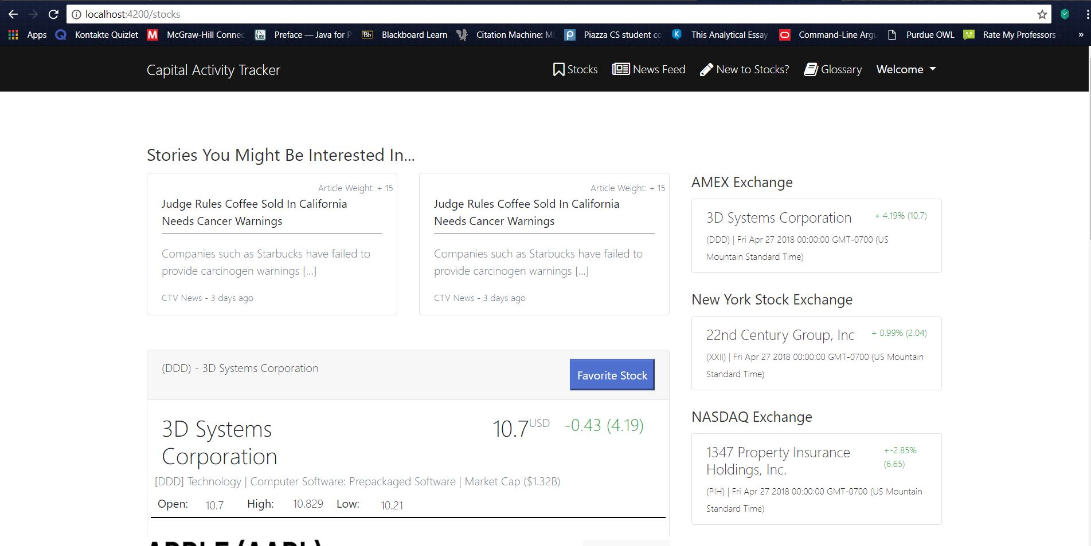

* Fix glossary page links
  + Link to Trello card(s): <https://trello.com/c/VvJDWGWd>
  + Name of who implemented the requirement: Kaitlyn
  + Link to the pull request on GitHub that refers to this implementation: https://github.com/kdl222/CAT/pull/19
  + Name of who reviewed and approved the pull request: Savannah Fischer
  + GitHub Link to the automated testing code of the feature (for this release, all features should have automated tests): We cannot do automated tests, as stated above.
  + A print screen that depicts the implemented feature:

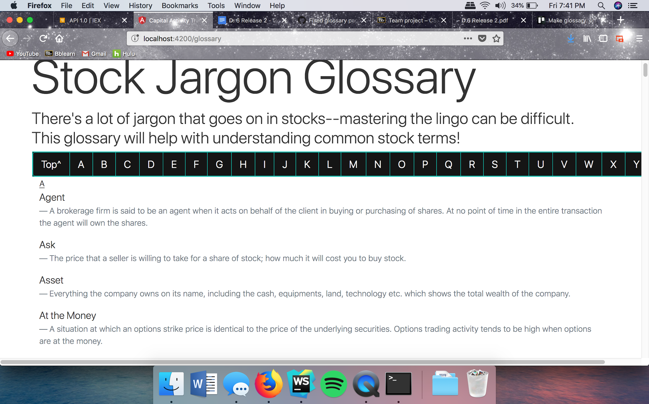

* Make stock page load faster
  + Link to Trello card(s): <https://trello.com/c/Qe57QrAl>
  + Name of who implemented the requirement: Kaitlyn
  + Link to the pull request on GitHub that refers to this implementation: <https://github.com/kdl222/CAT/pull/16>
  + Name of who reviewed and approved the pull request: Savannah Fischer
  + GitHub Link to the automated testing code of the feature (for this release, all features should have automated tests): We cannot do automated tests, as stated above.
  + A print screen that depicts the implemented feature: (is a file not a page on our web app) 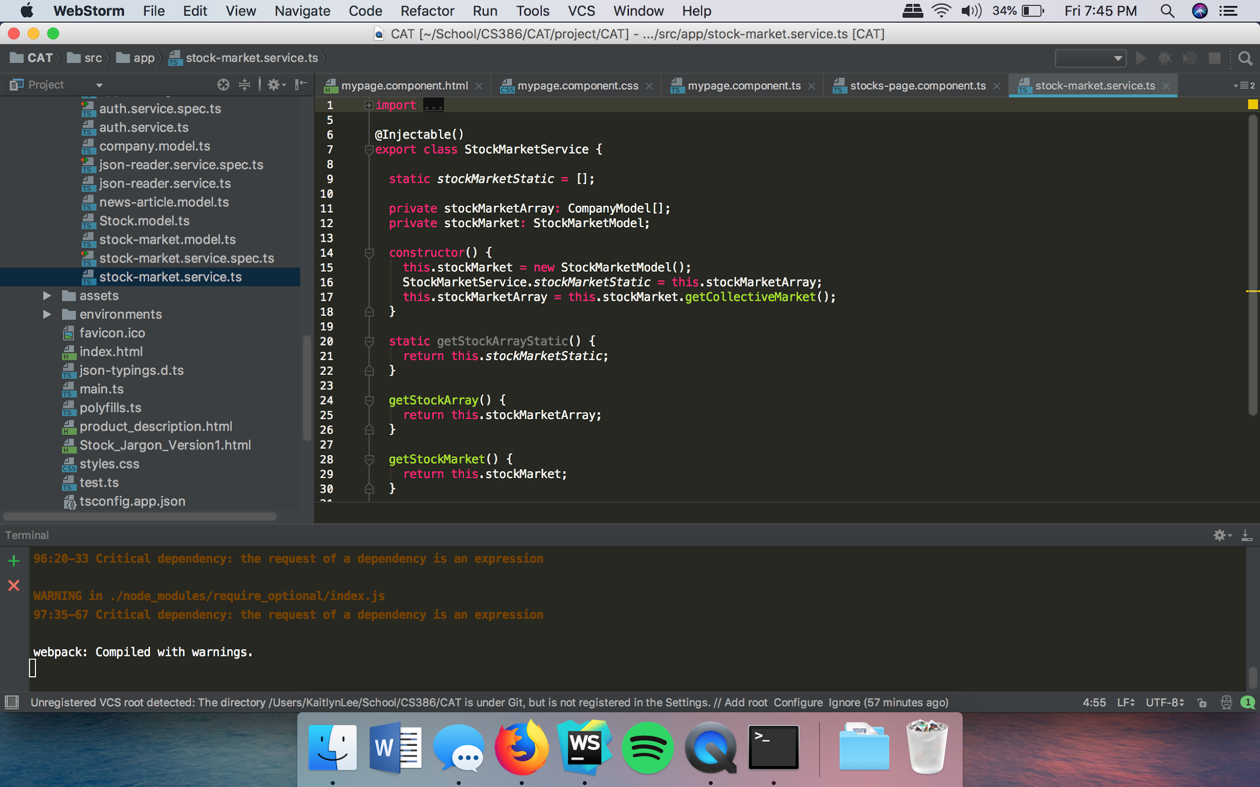
* Fixed HTML ‘vocabulary’ into Angular ‘vocabulary’ in code for better functionality; changed HTML href into Angular routerLink on multiple code files
  + Link to Trello card(s): https://trello.com/c/RiPdr1d0/
  + Name of who implemented the requirement: Savannah
  + Link to the pull request on GitHub that refers to this implementation: https://github.com/kdl222/CAT/pull/15
  + Name of who reviewed and approved the pull request: (Savannah merged in error; Kaitlyn was showing how GitHub works) Kaitlyn approved pull request
  + GitHub Link to the automated testing code of the feature (for this release, all features should have automated tests): We cannot do automated tests, as stated above.
  + A print screen that depicts the implemented feature: (includes multiple code files; will only show one)

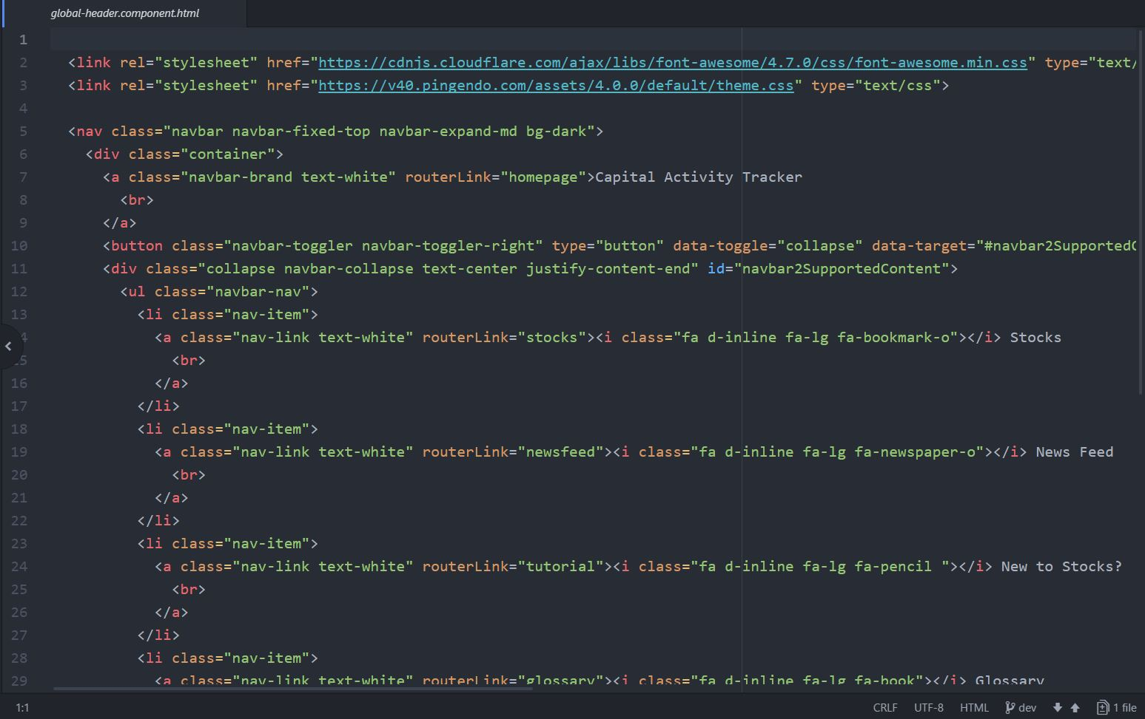

1. **Demo**

<https://drive.google.com/file/d/1tg4d6oyXek1WTOVtysxzHSk76gAIPAvv/view?usp=sharing>

1. **Group Participation**

**Kaitlyn Lee: (65%)**  Recorded three pull requests and recorded the demo

**Brandon Horner:** **0%**

**Savannah Fischer: (35%)** Recorded two pull requests and completed the Description section

**Clayton Williams: 0%**